Commodore PET/CBM80xx/40xx Diagnostic Keyboard PCB **Rev. 0**

**Module Description**

# Introduction

The Keyboard PCB is part of the Diagnostic Clip project. Originally, it was made with a connector and wires, but since PCBs got cheap and provide interconnects very reproduceable with a low failure rate, it is a very simple board design.

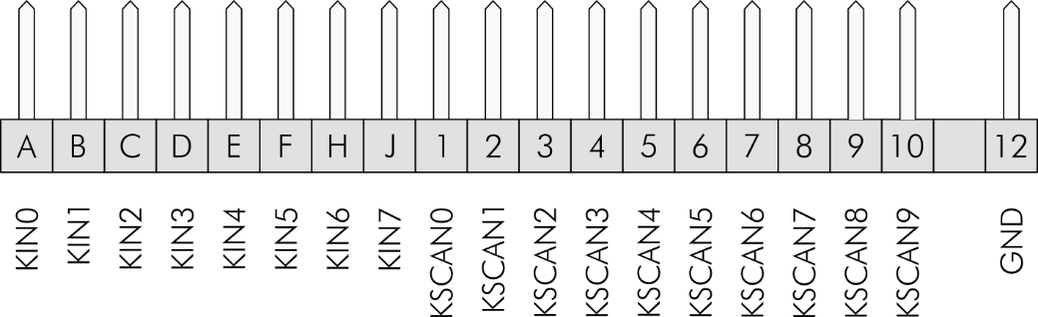

Figure 1: Pinout of the keyboard connector

KSCANx are the open collector outputs of a 74LS145 BCD to Decimal Decoder. So, it is not critical to connect more than one KeyScan Signal, nevertheless, the keyboard PCB provides diodes for a **wired-AND** connection, in case the slightly rare 74LS145 was replaced with another IC, that does not provide open collector outputs. The diodes could be replaced by a wire bridge.

|  |  |
| --- | --- |
| Pins | Connected Signals |
| A-1-9 | KIN0 - KeyScan0 - KeyScan8 |
| B-2-10 | KIN1 - KeyScan1 - KeyScan9 |
| C-3 | KIN2 - KeyScan2 |
| D-4 | KIN3 - KeyScan3 |
| E-5 | KIN4 - KeyScan4 |
| F-6 | KIN5 - KeyScan5 |
| H-7 | KIN6 - KeyScan6 |
| J-8 | KIN7 - KeyScan7 |

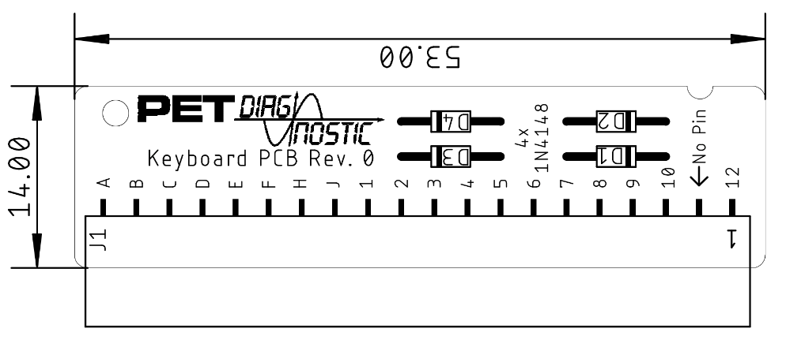

Figure 2: Dimensions of the Keyboard PCB

Revision History

Rev. 0

* Fully functional prototype